Accruent Credentials – First Time Logging In

- First thing’s first, go to https://portal.office.com, and sign in with your Accruent Office 365 username and password.
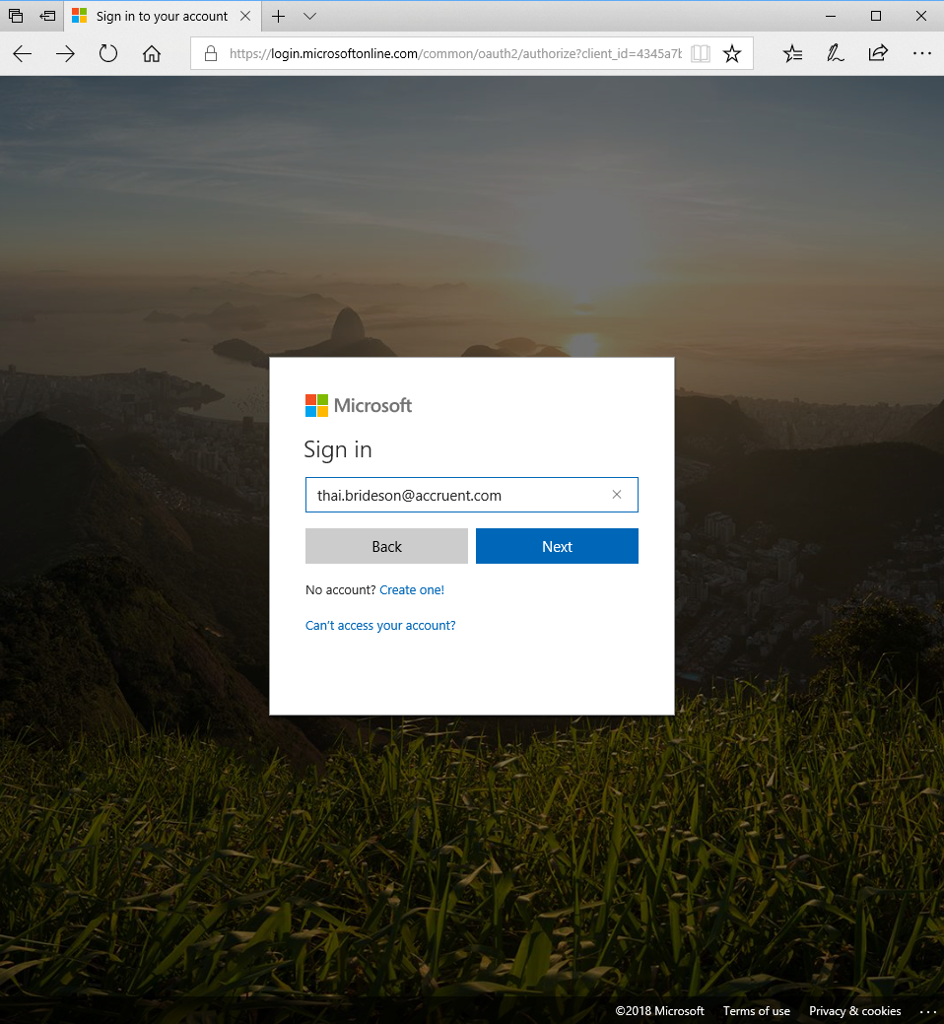
- Once you enter in your Office 365 username (hint: it’s your email address), it will switch over to the Accruent branding.
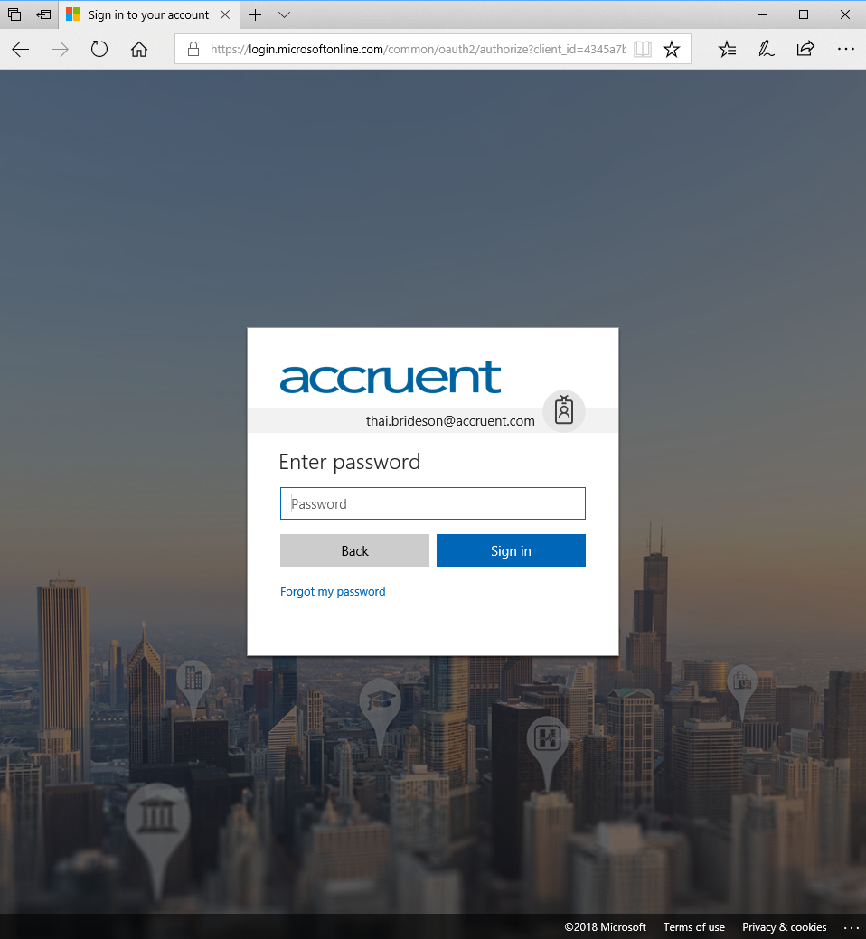
- It will take you to this page so that you can set up your Multi-Factor Authentication configuration page. Select “Set it up now” to get it configured.
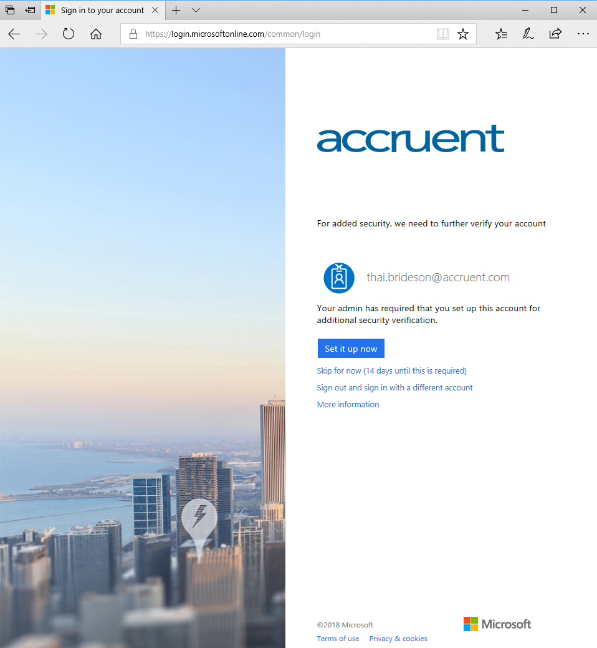
- The most common authentication method would be to set up your cell phone as the primary device. Enter in your number and select whether you’d like it to send you a code via text, or call you directly, then click “Next.”
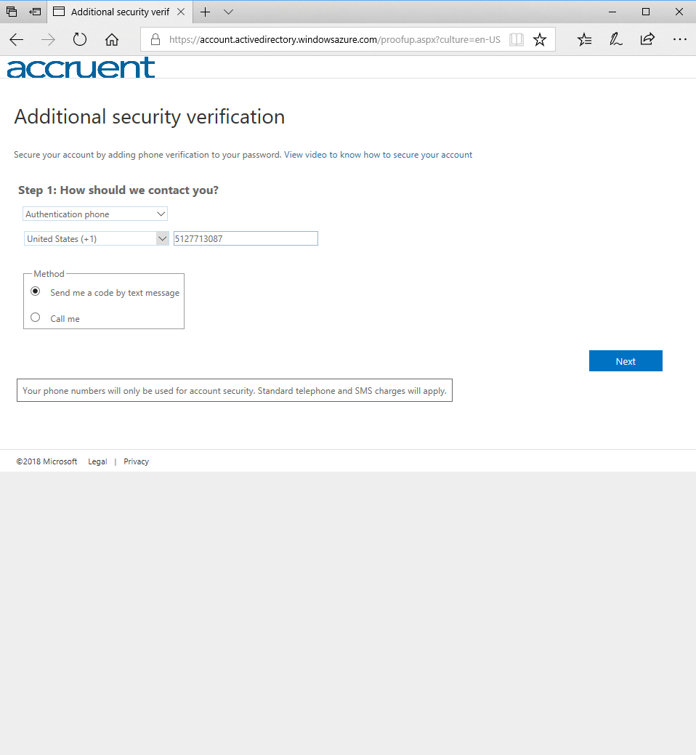
- It will process and then give you a box to enter in the code. Once you enter it and click “Verify,” it will complete this first step.
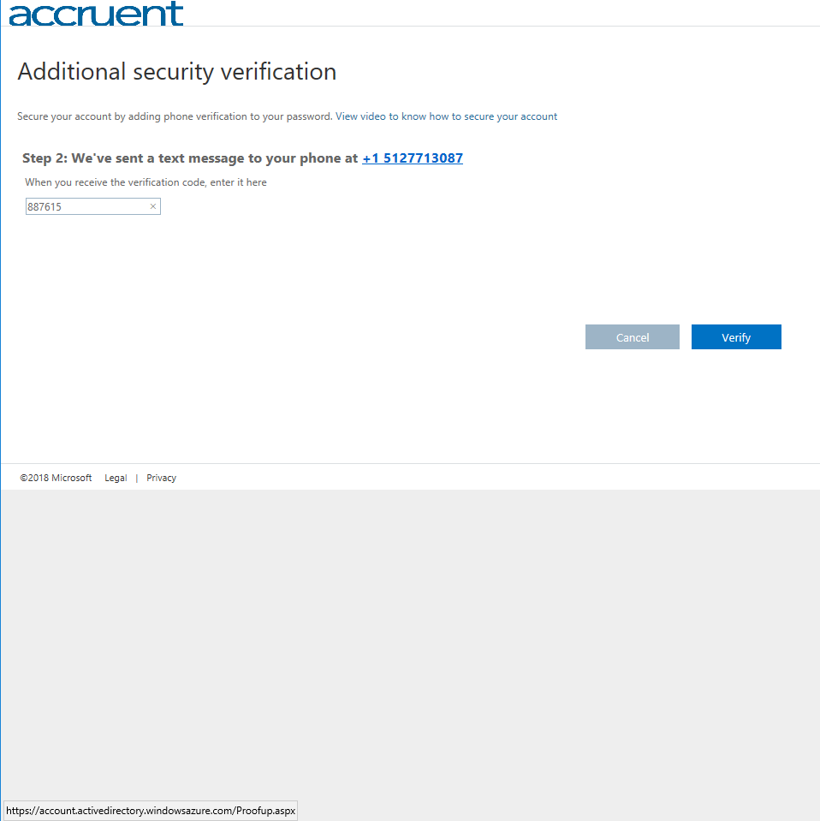
- Click “Done” and it will move you on to the next step.
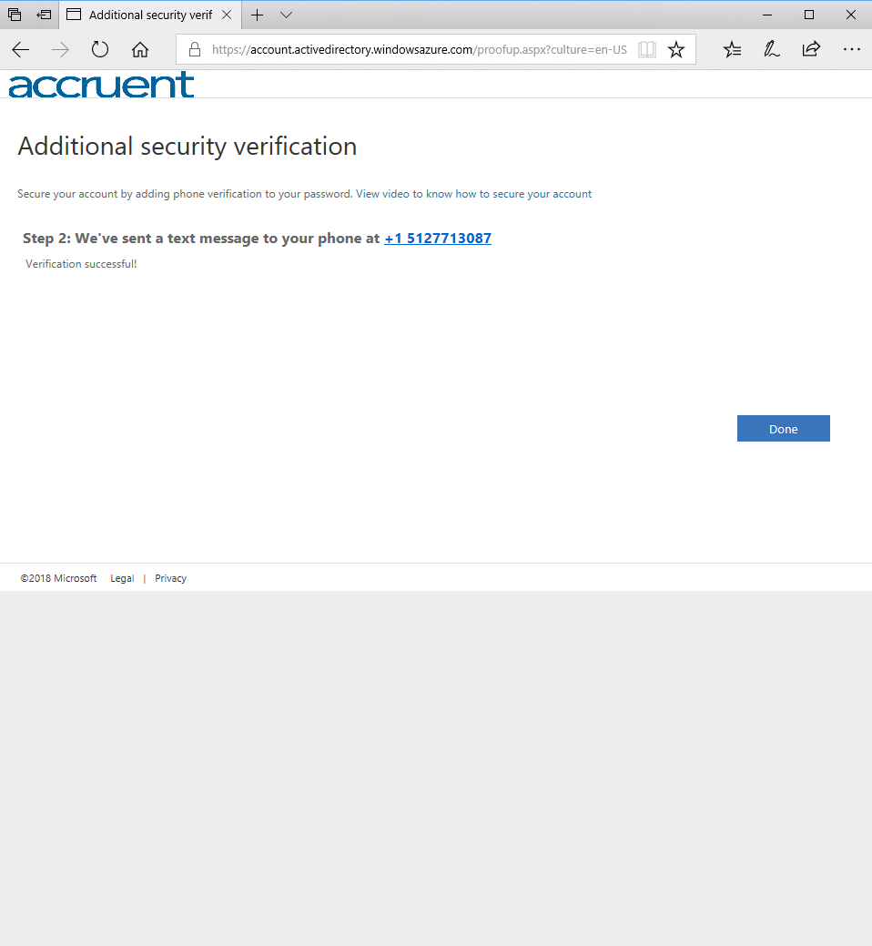
- Click “Next” to proceed on to the addition set up.
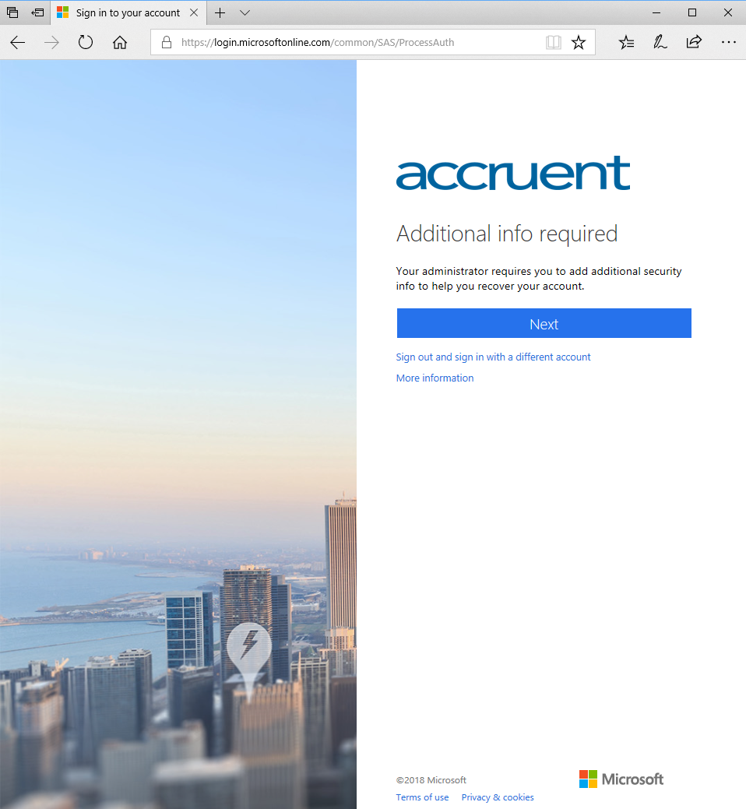

- Once you’ve set all of those up, you’ll get this screen that denotes that you are all finished setting up your Multi-Factor Authentication options.

- Now let’s get your Confluence account all set up. You should have an email in your Accruent mailbox that is an invitation to join your team in Confluence.
Click on the Outlook tile to go to your webmail and find the email.
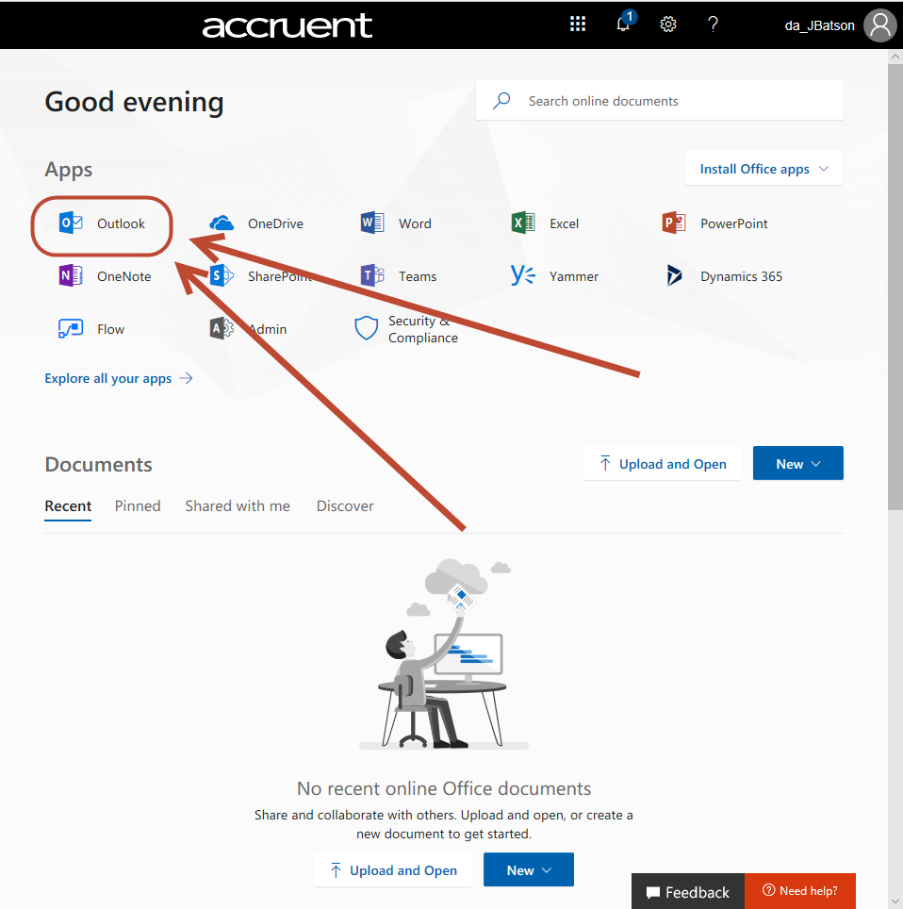
- Click on the “Join them now” button.
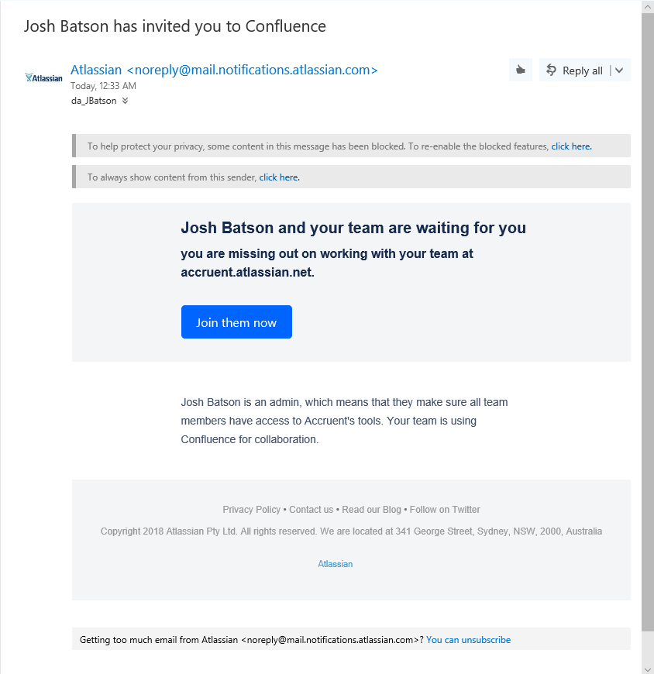
- You can upload a photo for your profile here, or just skip this part.
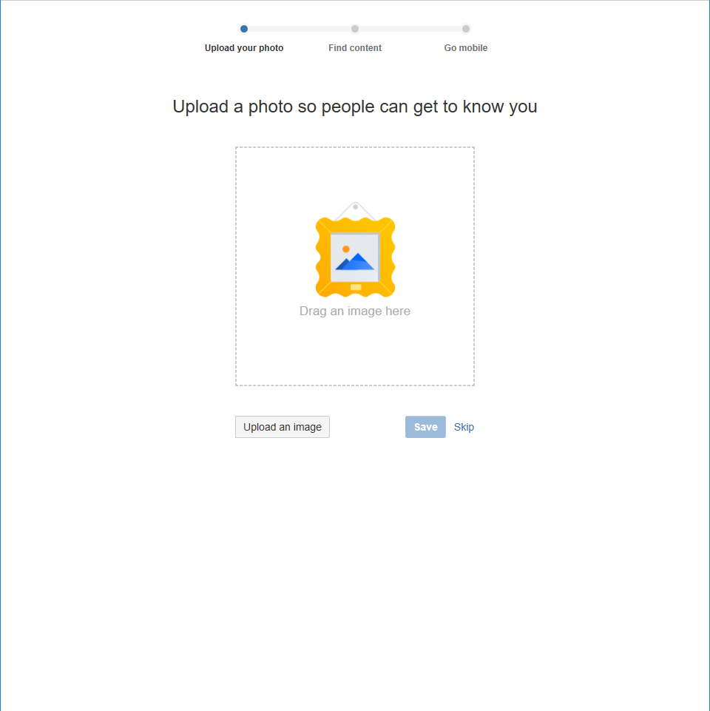
- On the next step, you can join or follow some of the Spaces that are already in Confluence. I highly recommend searching for and following the “Accruent Home Page.” This is the main intranet page for Accruent. Check the box to the right, and then click the “Continue” box at the below.
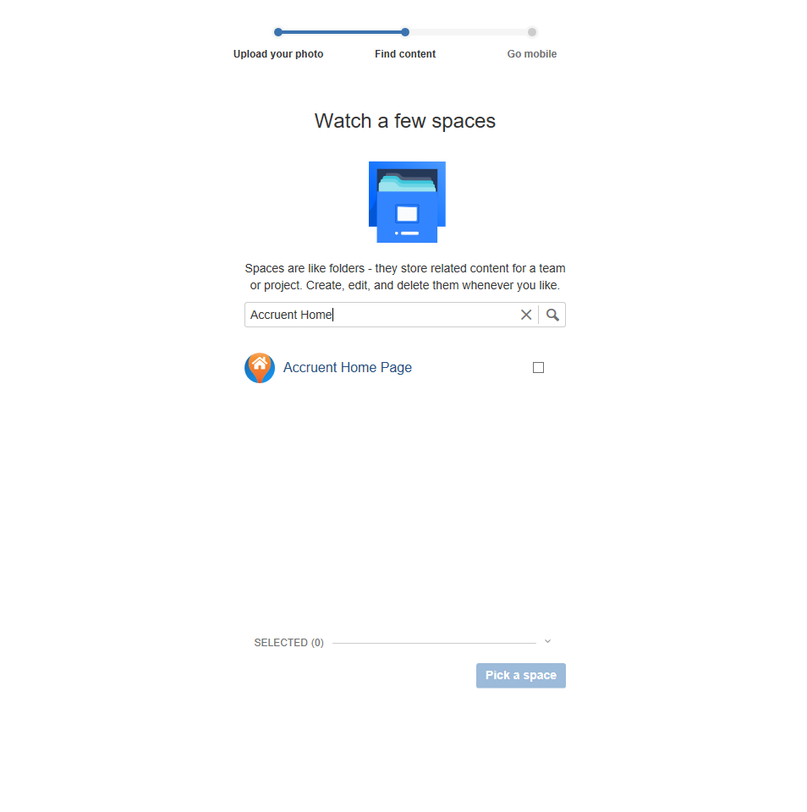
- You’re all done. You can download and install Confluence on mobile devices from this page. Click on the “Take me to Confluence” button to finish the setup and go on to the site.
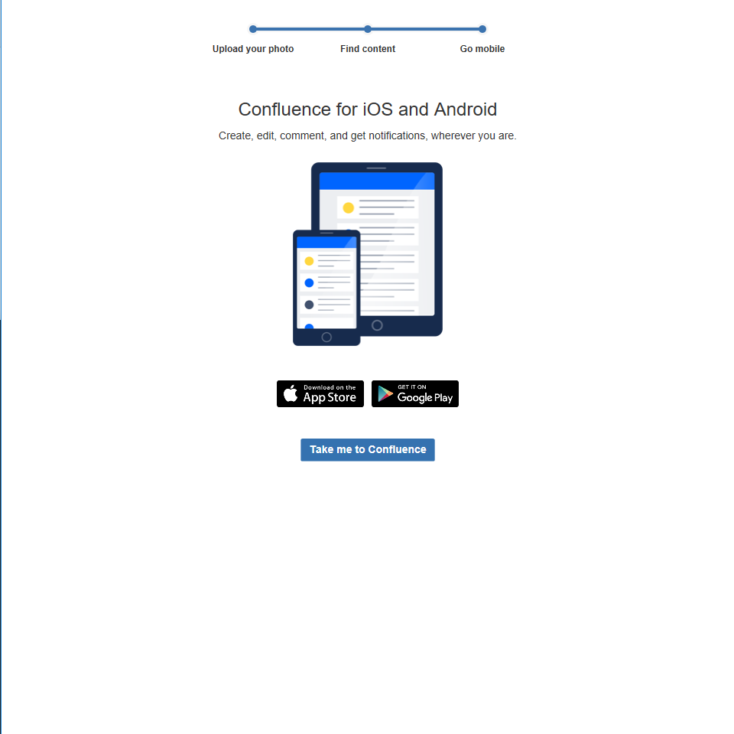
- This is the main home page. We have almost all of the departments and teams here to easily navigate to, in addition to a lot of the commonly used tools for Accruent employees.
Go here for a general walkthrough of Confluence and it’s different features.
